From Chaos to Clarity: Five Critical Lessons in Building Reliable Enterprise Multi-Agent Systems

Overview
When a mid-sized technology company approached us at ZOKFORCE to help design an HR talent management system powered by multiple AI agents, we thought we understood the challenges ahead. The business case was compelling: automate recruiting workflows, streamline onboarding, and reduce manual HR operations. The technical approach seemed straightforward: deploy specialized agents for each domain, coordinate them through a central orchestrator, and let AI handle the heavy lifting.
We were wrong about how straightforward it would be.
What followed was six months of trial, error, and hard-won insights that fundamentally changed how we approach multi-agent system development. This article shares the journey—not a polished success story with clean metrics, but the messy reality of building complex AI systems, the mistakes we made, and the lessons that emerged from navigating those challenges.

The Promising Beginning
The initial architecture looked elegant on paper. We designed five specialized agents working in concert:
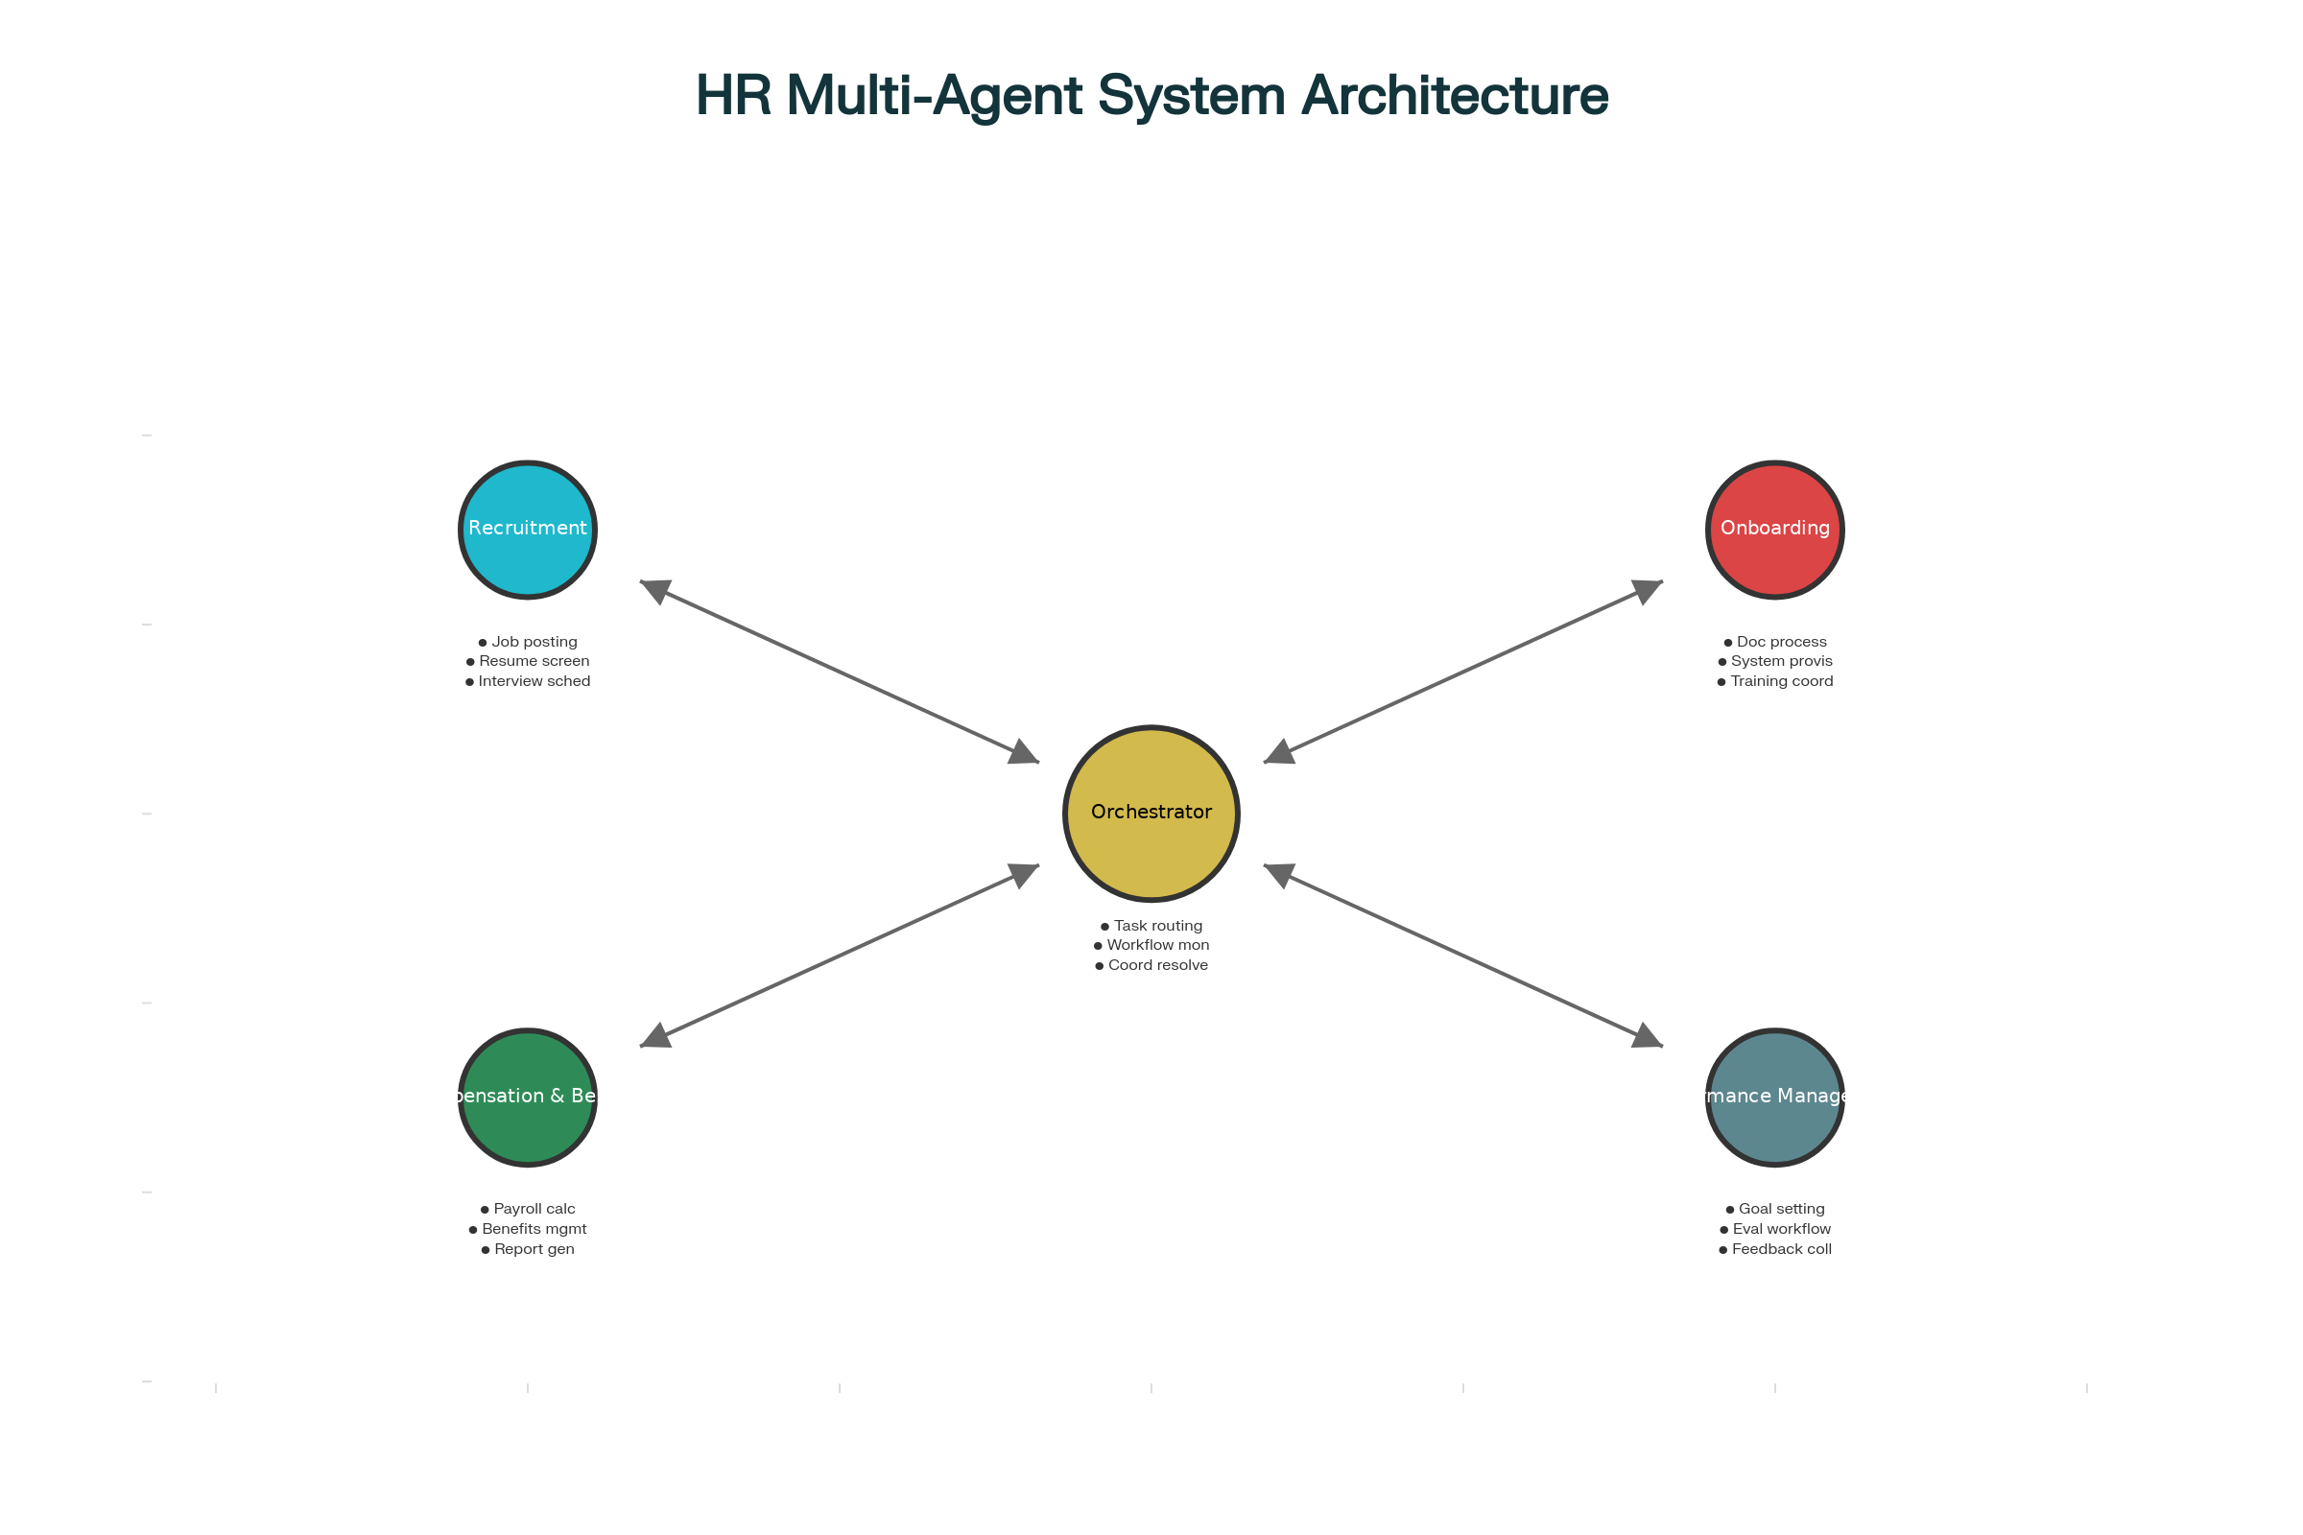
Enterprise HR Multi-Agent System Architecture

The Plan:
- Recruitment Agent: Handle job postings, screen resumes, schedule interviews
- Onboarding Agent: Coordinate document processing, system access, training schedules
- Compensation & Benefits Agent: Calculate payroll, manage benefits, generate reports
- Performance Management Agent: Set goals, manage evaluation workflows, collect feedback
- Orchestrator Agent: Route tasks, monitor workflows, resolve conflicts
Each agent would operate independently within its domain while the orchestrator ensured smooth handoffs. The client's HR team could focus on strategic work while agents handled routine operations.
The demo worked beautifully. We showed the system processing a sample recruiting workflow from job posting to offer letter in minutes, with agents seamlessly passing information between each other.
Then we tried to deploy it.

Lesson 1: The Specification Trap—When "Clear" Instructions Aren't Clear Enough

What Went Wrong
Within the first week of testing with real data, the Recruitment Agent began behaving erratically. It would successfully screen 10 resumes, then suddenly reject all candidates for a position despite them meeting the criteria. When we reviewed the execution logs, we discovered a fundamental problem: our instructions were ambiguous.^{[1][2]}
We had told the agent to "screen resumes for qualified candidates based on job requirements." Sounds clear, right? But we hadn't defined:
- What "qualified" meant in measurable terms
- How to handle edge cases (e.g., candidates slightly below experience requirements but with exceptional skills)
- What to do when job requirements conflicted (10 years experience required for entry-level salary)
- When to escalate uncertain decisions versus making autonomous choices
The agent filled these gaps with its own interpretations—which changed unpredictably across runs.^{[3][1]}

The Deeper Issue
This revealed what research calls specification errors—the most common failure mode in multi-agent systems, accounting for 32-42% of failures. The problem isn't that LLMs don't understand instructions; it's that they're incredibly good at finding valid interpretations we never considered.^{[4][2][3]}
One particularly memorable failure occurred when the Onboarding Agent was told to "set up accounts for new hires." For one employee, it created accounts across all systems. For the next, it only created email access. For a third, it created duplicate accounts in the HR database. Same instruction, three different interpretations, no consistency.

What We Learned
Be ruthlessly specific. Instead of "screen resumes for qualified candidates," we rebuilt the instruction as:
Evaluate each resume against the following criteria:
1. Required qualifications (must have ALL):
- [List with exact matching rules]
2. Preferred qualifications (weight each):
- [List with scoring rubric]
3. Disqualifying factors (immediate rejection):
- [Explicit list]
For candidates scoring 80-100: Auto-advance
For candidates scoring 60-79: Flag for human review with specific gaps identified
For candidates scoring below 60: Auto-reject with reason code
If any criterion is ambiguous or missing from the resume, mark as "INSUFFICIENT_INFO" and request clarification.
Even this wasn't enough. We had to add constraint validation—the agent must first confirm it has all required information before processing, and it must output its scoring in a structured format we could programmatically verify.^{[1][5]}

Takeaway
Multi-agent systems magnify specification problems. What causes minor inconsistency in a single agent becomes catastrophic when agents make sequential decisions based on prior ambiguous outputs. Specification is not a prompt engineering problem; it's a system design problem.

Lesson 2: The Coordination Nightmare—When Agents Can't Talk to Each Other

What Went Wrong
Our next crisis emerged when we tried to process an actual employee through the recruiting-to-onboarding pipeline. The Recruitment Agent successfully processed a candidate and sent a message to the Onboarding Agent: "Candidate John Smith has been hired."
The Onboarding Agent received it and responded: "Who is John Smith? I need employee ID, start date, department, manager, and salary band."
The Recruitment Agent didn't have that information—it lived in systems the Recruiting Agent didn't access. The handoff failed.^{[6][3]}
We went back and forth for days trying to fix the communication protocol. We added more fields to the message. Then the Compensation Agent complained it needed different fields. We added those. Then the Performance Management Agent needed yet another data structure.
Within two weeks, we had five different message formats, zero interoperability, and agents that simply stopped responding when they received unexpected input.^{[7][8]}

The Deeper Issue
This is the coordination failure problem that plagues 28-31% of multi-agent deployments. Each agent was functionally correct in isolation, but their collective behavior was chaotic. The problem compounds exponentially:^{[6][4][3]}
- 2 agents = 1 potential coordination point
- 4 agents = 6 potential coordination points
- 5 agents (our system) = 10 potential coordination points
Every interaction was an opportunity for miscommunication, data loss, or format mismatch.^{[7][5]}

What We Learned
Standardize communication radically. We scrapped our ad-hoc messaging and implemented a universal message schema:
{
"message_id": "uuid",
"conversation_id": "uuid",
"sender_agent": "recruitment",
"receiver_agent": "onboarding",
"message_type": "TASK_DELEGATION",
"timestamp": "ISO8601",
"payload": {
"action": "initiate_onboarding",
"entity_id": "emp_12345",
"entity_type": "employee",
"required_data": {
"employee_info": {...},
"employment_details": {...}
},
"context": {
"previous_stage": "recruitment",
"approval_status": "complete"
}
},
"callback_required": true,
"callback_timeout_seconds": 300
}
More importantly, we implemented strict interface contracts. Each agent publishes a schema defining exactly what data it requires and what it outputs. The orchestrator validates every message against these contracts before delivery.^{[5][9]}
If an agent tries to send incomplete data, the message is rejected at the boundary—not after the receiving agent has already tried to process it and failed mysteriously.

Takeaway
Don't let agents invent their own communication patterns. The flexibility of LLMs is both their strength and their weakness in multi-agent systems. You must impose structure that the models wouldn't create themselves.

Lesson 3: The Memory Fragmentation Problem—When Context Disappears

What Went Wrong
Three weeks into testing, we encountered our most perplexing failure. An HR manager asked the system: "What's the status of Sarah Chen's onboarding?"
The Orchestrator routed this to the Onboarding Agent, which responded: "Sarah Chen's laptop has been ordered."
The manager followed up: "When will it arrive?"
The agent responded: "I don't have information about any laptop orders."
The agent had forgotten what it said 30 seconds ago.^{[7][10]}
Digging deeper, we discovered the agent couldn't actually remember the laptop was ordered—it had retrieved that information in response to the first query, generated a response, then immediately forgot. When asked the follow-up question, it had no context from the previous interaction.
This wasn't an isolated incident. Agents routinely "forgot" decisions they'd made, contradicted information they'd just provided, or asked for data they'd already received.^{[6][8]}

The Deeper Issue
This is the context fragmentation problem—each agent maintains its own ephemeral working memory, and that memory disappears as soon as the conversation moves on. In enterprise workflows that span hours or days, this creates fundamental reliability problems.^{[7][5]}
Even worse, when multiple agents need to work together, they each have different partial views of the situation. The Recruitment Agent knew the candidate had negotiated a higher salary. The Onboarding Agent didn't. The Compensation Agent processed the standard offer amount. Three agents, three different realities, one very angry new hire.

What We Learned
We implemented a three-tier memory architecture:^{[5][11]}

Tier 1: Session Memory (ephemeral)
- Scope: Current conversation only
- Storage: Redis cache with 30-minute TTL
- Contents: Active dialogue history, temporary variables
- Purpose: Enable natural multi-turn conversations

Tier 2: Task Memory (persistent)
- Scope: Duration of a business workflow
- Storage: PostgreSQL with workflow_id as key
- Contents: All decisions, data accessed, actions taken
- Purpose: Maintain continuity across agent handoffs

Tier 3: Shared Knowledge Base (permanent)
- Scope: All agents, all time
- Storage: Vector database + structured data
- Contents: Employee records, policies, historical decisions
- Purpose: Provide consistent ground truth
Critically, we added conversation history injection—before any agent processes a request, the orchestrator provides it with the complete relevant context from prior interactions, not just the immediate query.^{[9][5]}

Takeaway
Memory in multi-agent systems isn't optional; it's foundational. LLMs are stateless by default. Multi-agent coordination requires explicit state management or your system will exhibit severe amnesia that destroys user trust.

Lesson 4: The Verification Gap—When Nobody Checks the Work

What Went Wrong
One morning, the client's CFO sent an urgent email: "Why did we just process payroll with a 300% salary increase for the entire engineering team?"
Panic ensued. We investigated and found the chain of events:
- Performance Management Agent recommended merit increases (correctly: 3-5%)
- Compensation Agent processed the increases (incorrectly: interpreted 3-5% as 300-500%)
- Payroll systems executed (dutifully: paid what the agent specified)
No one caught the error. Each agent assumed the previous agent had done its job correctly. The system had no verification layer, no sanity checks, no "does this result make sense?" capability.^{[4][2]}
This was far from the only verification failure. We found:
- The Onboarding Agent created user accounts with obviously incorrect permissions
- The Recruitment Agent sent interview invitations to candidates who'd already been rejected
- The Performance Management Agent calculated performance scores using the wrong formula

The Deeper Issue
Verification gaps account for 21-24% of multi-agent failures, yet they're often the last thing teams implement. The assumption is that if each agent is "smart enough," the system will work. This is dangerously wrong.^{[4][2][3]}
The problem is that LLMs are confidence machines—they generate outputs with high confidence even when those outputs are nonsensical. In a multi-agent system, one agent's confident error becomes the next agent's confident input, creating cascading failures that nobody questions.^{[1][6]}

What We Learned
We implemented multi-layered verification:^{[11][12]}

Level 1: Structural Validation
- Every agent output is checked against a schema
- Type errors, missing fields, malformed data are caught immediately
- This is cheap and catches ~40% of errors

Level 2: Business Rule Validation
- Automated checks for business logic violations
- Examples: salary changes exceeding 20%, duplicate account creation, impossible dates
- This catches another ~35% of errors

Level 3: Cross-Agent Consistency Checks
- The orchestrator maintains invariants across agents
- Example: If Recruitment Agent marks someone as "hired," Onboarding Agent must have a corresponding task
- This catches ~15% of errors

Level 4: Confidence-Based Human Review
- Agents self-report confidence scores
- Low-confidence decisions automatically route to human review
- Catches edge cases and prevents silent failures (~10% of errors)
Critically, we made verification mandatory and blocking—agents cannot proceed to the next step until verification passes.^{[2][12]}

Takeaway
Trust but verify is a terrible strategy for AI systems—they're not trustworthy by default. Assume every agent output is potentially wrong and build systems that catch errors before they cascade.

Lesson 5: The Complexity Explosion—When More Agents Make Things Worse

What Went Wrong
As the system stabilized, the client requested new features. "Can we add a compliance agent to check labor law requirements? And a learning & development agent for training? And a analytics agent for HR insights?"
We said yes. After all, the architecture was modular. Adding agents should be straightforward.
It wasn't.^{[13][14]}
Each new agent exponentially increased system complexity:
- More agents = more coordination points
- More coordination = more failure modes
- More failure modes = more debugging time
- More debugging = slower development
By agent seven, we were spending 80% of our time debugging coordination issues and only 20% on actual features. Worse, the system became so complex that even we couldn't reliably predict how it would behave.^{[7][15]}
The final straw came when the compliance agent and the compensation agent entered an infinite loop—the compliance agent flagged a payroll calculation as potentially non-compliant, the compensation agent recalculated, the compliance agent flagged the new calculation, repeat forever. The system deadlocked for 47 minutes before timing out.^{[8][7]}

The Deeper Issue
This is the combinatorial explosion problem. Coordination costs scale quadratically with agent count. A four-agent system has 6 coordination paths. A seven-agent system has 21. A ten-agent system has 45.^{[7][13]}
Research confirms this brutal reality: Adding more agents often decreases performance. The coordination overhead outweighs the benefits of specialization.^{[1][13][7]}

What We Learned
We radically simplified:^{[13][14]}

Decision 1: Merge Agents
- Combined compliance checking into the compensation agent (same domain)
- Merged learning & development into performance management (shared workflow)
- Reduced seven agents back to five

Decision 2: Limit Direct Agent-to-Agent Communication
- Implemented hub-and-spoke instead of mesh architecture
- All communication flows through the orchestrator
- Eliminated agent-to-agent dependencies

Decision 3: Single-Agent-First Rule
- Before adding a new agent, we ask: "Can an existing agent handle this with better prompting?"
- New agents are only added when single-agent solutions clearly fail
The result? System reliability improved dramatically. Response times decreased. Debugging became tractable. The team could actually reason about system behavior.

Takeaway
More agents is not always better—often it's worse. Multi-agent systems are powerful for truly independent tasks but quickly become unmanageable when tasks require frequent coordination. Simplicity is a feature, not a limitation.

The Bigger Picture: What We Wish We'd Known
Looking back, these lessons share a common thread: multi-agent systems fail not because of AI limitations, but because of architectural and design decisions.^{[1][3]}
The failures we encountered match industry research remarkably well:
- 32% specification errors^{[4][2]}
- 28% coordination failures^{[6][4]}
- 24% verification gaps^{[2][4]}
- Plus cascading complexity as systems scale^{[7][13]}

What we would do differently:

Start Simple, Stay Simple
- Begin with a single intelligent agent
- Only introduce multiple agents when you have concrete evidence one agent can't handle it
- Resist the temptation to add agents for modularity alone

Invest in Observability First
- Build comprehensive logging before you build agents
- Track every decision, every data flow, every handoff
- Make system behavior transparent—you'll need it for debugging

Design for Failure
- Assume agents will misunderstand, miscommunicate, and make mistakes
- Build verification and recovery mechanisms from day one
- Create clear escalation paths to human oversight

Test Ruthlessly
- Use real data, not synthetic examples
- Test edge cases and error conditions explicitly
- Expect the system to fail in surprising ways

Where We Are Now
Six months later, the HR system is running in production. It's not perfect, and it requires ongoing monitoring and adjustment. But it works reliably enough that the HR team trusts it with real workflows.
More importantly, we've internalized these lessons for future multi-agent projects. We now approach them with appropriate caution, starting simple and adding complexity only when justified by clear benefits.
The promise of multi-agent AI is real—specialized agents can tackle complex enterprise workflows that single agents struggle with. But the path from prototype to production is filled with subtle coordination failures, cascading errors, and emergent behaviors that no demo can predict.
Success requires not just powerful AI models, but thoughtful system design, rigorous testing, and the humility to simplify when complexity becomes unmanageable.

Have questions about multi-agent system implementation? Contact our service team at ZOKFORCE for a consultation: service@zokforce.com | www.zokforce.com

